Valuation Report

Of

Mr. Bharat Tarachand Suthar & Mrs. Mamta Bharat Suthar
(Proposed Purchaser)

At

Flat No. 3305, 33rd Habitable Floor, Wing-B, Shreeji Sky Rise Tower, Ambewadi, Opp. Fire Brigade, S.V. Road, Kandivali (W),
Mumbai-400067.

For

Bank Of India, RBC Thane Branch

TO,
BANK OF INDIA
BRANCH: RBC THANE
VALUATION REPORT
(IN RESPECT OF FLAT)

Ref. No. UCVLLP/BOI/7314 Date: 28/03/2025
I. | GENERAL
1. | Purpose for which the valuation is made |  | :
2. | a) | Date of inspection | :
 | b) | Date on which the valuation is made | :
3. | List of documents produced for perusal
 | Agreement |  | :
 | Index-II |  | :
 | Commencement Certificate |  | :
 | Title report
 | Other Documents
4. | Name of the owner(s) and his / their address (es) with Phone no. (details of share of each owner in case of joint ownership) |  | :
5. | Brief description of the property |  | : | Accommodation:  Amenities:  Area:
6. | Location of property
 | a) | Plot No. / Survey No. | :
 | b) | Door No./ Shop No. | :
 | c) | T. S. No. / Village | :
 | d) | Ward / Taluka | :
 | e) | Mandal / District | :
 | f) | Date of issue and validity of layout of approved map / plan | :
 | g) | Approved map / plan issuing authority | :
 | h) | Whether genuineness or authenticity of approved map / plan is verified | :
 | i) | Any other comments by our empaneled valuers on authentic of approved plan | :
7. | Postal address of the property
8. | City / Town |  | :
 | Residential Area |  | :
 | Commercial Area |  | :
 | Industrial Area |  | :
9. | Classification of the area |  | :
 | i) | High / Middle / Poor | :
 | ii) | Urban / Semi Urban / Rural | :
10 | Coming under Corporation limit / Village Panchayat / Municipality |  | :
11 | Whether covered under any State / Central Govt. enactments (e.g., Urban Land Ceiling Act) or notified under agency area / scheduled area / cantonment area |  | :

12 | Boundaries of the property | : | Building Boundaries | Flat Boundaries
 | North | :
 | South | :
 | East | :
 | West | :
13 | Dimensions of the site | : | A | B
 |  |  | As per Draft Agreement | Actuals
14 | Extent of the site | :
14.1 | Latitude, Longitude & Co-ordinates of Flat | :
15 | Extent of the site considered for valuation (least of 13 A & 13 B) | :
16 | Whether occupied by the owner / tenant? If occupied by tenant, since how long? Rent received per month. | :
II. | APARTMENT BUILDING
1. | Nature of the Apartment | :
2. | Location | :
 | C.T.S. No. | :
 | Block No. | :
 | Ward No. | :
 | Village/ Municipality / Corporation | :
 | Door No., Street or Road (Pin Code) | :
3. | Description of the locality Residential / Commercial / Mixed | :
4. | Year of Construction | :
5. | Number of Floors | :
6. | Type of Structure | :
7. | Number of Dwelling units in the building | :
8. | Quality of Construction | :
9. | Appearance of the Building | :
10 | Maintenance of the Building | :
11 | Facilities Available:
 | Lift | :
 | Protected Water Supply | :
 | Underground Sewerage | :
 | Car Parking - Open/ Covered | :
 | Does Compound wall exist? | :
 | Is pavement laid around the building | :
III | FLAT:
1 | The floor on which the Flat is situated | :
2 | Door No. of the Flat No. | :
3 | Specifications of the Flat | :
 | Roof | :
 | Flooring | :
 | Doors | :
 | Windows | :
 | Fittings | :
 | Finishing | :
4 | House Tax | :
 | Assessment No. | :
 | Tax paid in the name of | :
 | Tax amount | :
5 | Electricity Service Connection no. | :
 | Meter Card is in the name of | :
6 | How is the maintenance of the Flat? | :
7 | Sale Deed executed in the name of | :
8 | What is the undivided area of land as per Sale Deed? | :
9 | What is the plinth area of the Flat? | :
10 | What is the floor space index (app.) | :
11 | What is the Carpet Area of the Flat? | :
12 | Is it Posh/ I class / Medium / Ordinary? | :
13 | Is it being used for Residential or Commercial purpose? | :
14 | Is it Owner-occupied or let out? | :
15 | If rented, what is the monthly rent? | :

IV | MARKETABILITY
1 | How is the marketability? | :
2 | What are the factors favouring for an extra Potential Value? | :
3 | Any negative factors are observed which affect the market value in general? | :

V | Rate:
1 | After analysing the comparable sale instances, what is the composite rate for a similar Flat with same specifications in the adjoining locality? |  | : | Rs. 28,000/- to Rs. 30,000/- per sq. ft on Carpet Area depending upon location and amenities
2 | Assuming it is a new construction, what is the adopted basic composite rate of the Flat under valuation after comparing with the specifications and other factors with the Flat under comparison (give details). |  | : | Rs. 28,000/- to Rs. 30,000/- per sq. ft on Carpet Area depending upon location and amenities  Rate adopted: Rs. 29,000/- on Carpet Area
3 | Break - up for the rate |  | :
 | i) | Building + Services | :
 | ii) | Land + Others | :
4 | Guideline rate obtained from the Registrar's Flat (evidence thereof to be enclosed) |  | :

VI | COMPOSITE RATE ADOPTED AFTER DEPRECIATION
a. | Depreciated building rate
 | Replacement cost of Flat with Services (v (3)i) | :
 | Age of the building | :
 | Life of the building estimated | :
 | Depreciation percentage assuming the salvage value as 10% | :
 | Depreciated Ratio of the building | :
b. | Total composite rate arrived for valuation | :
 | Depreciated building rate VI (a) | :
 | Rate for Land & other V (3) ii | :
 | Total Composite Rate | :

Details of Valuation:
Sr. No. | Description | Carpet Area  (sq.ft.) | Rate per unit Rs. | Estimated Value Rs.
1 | Present value of the Flat | 827 | 29,000/- | 2,39,83,000/-
2 | Wardrobes | --- | --- | ---
3 | Showcases | --- | --- | ---
4 | Kitchen Arrangements | --- | --- | ---
5 | Superfine Finish | --- | --- | ---
6 | Interior Decorations | --- | --- | ---
7 | Electricity deposits / electrical fittings, etc., | --- | --- | ---
8 | Extra collapsible gates / grill works etc., | --- | --- | ---
9 | Potential value, if any | --- | --- | ---
10 | Car Parking | 1 | 10,00,000/- | 10,00,000/-
 | Value of Property |  |  | 2,49,83,000/-
 | Say (After 100% Completion of all works) |  |  | 2,50,00,000/-
 | As per current stage of 50% work completion the value of property is |  |  | 1,25,00,000/-

As a result of my appraisal & analysis, it is my considered opinion that the present market value of the above property in the prevailing condition with aforesaid specifications Value Rs. 2,50,00,000/- (Rupees Two Crore Fifty Lakhs Only) (After 100% Completion of all works).

i) | Fair Market Value
ii) | Realizable value (95% of Fair Market Value)
iii) | Distress value (80% of Fair Market Value)
iv) | Insurance Value
vi) | Government Value
v) | Purchase Price of immovable property

i) | Fair Market Value (As on date of 50% completion)
ii) | Realizable value (95% of Fair Market Value) (As on date of 50% completion)
iii) | Distress value (80% of Fair Market Value) (As on date of 50% completion)

Remarks:
- Report finalized on the basis of site visit and copy of: Draft Agreement, C.C., Floor Plan, Brochure, Title report, etc. for verification purpose. However, we have not been provided with latest registered Agreement/Index-II, Approved plan, etc. for Verification Purpose.
- The said property is in under construction stage.
- Currently RCC work completed upto 45th slab and Brickwork completed upto 18th floor and remaining work is under progress.
- At present only 50% of the building work is completed, hence the current value is given as per the work completion at site.
- Project name was displayed at site.
- Property is situated in residential cum Commercial area.
- Property is inspected as shown by persons met on site Ms. Soni Ghodla- Sales executive.
- The value given is considering all the Surrounding area locational & advantage of the said property.
- We consider the area given in the Draft Agreement declared by the party and submitted for registration with the government authorities as final for valuation purpose. Any area that is not stated in the Draft Agreement is not considered for valuation unless the area is measured by us in which case that may be considered for valuation purpose.
- The scope of our valuation work is only for banks financial/loan purpose. Further, please be noted that this report shall not be used for any litigation purpose.
- Encumbrance of Loan, Government and other dues, stamp duty, registration charges, transfer charges etc., if any are not considered in the valuation. We assumed that the assets are free from encumbrance unless otherwise stated to us by the party in writing.
- The value given in our report is the estimate of the Fair Market value of the property as on date, considering various aspects of the property as mentioned above.
- The value given in the report is the estimate of the Fair Market value of the property as on date, considering various aspects of the property like amenities in projects, locational advantages, demand and supply equation, interior designing done in the property, outside view, Vastu aspects etc., which is generally more than the Government ready reckoner value.

DECLARATION
We further declare that:
- The information furnished in this report is true and correct to the best of our knowledge and belief.
- Our Engineer, Mr. Suraj has personally inspected and valued the right property on 25/03/2025.
- We have no present or prospective interest in the property that is the subject of this report, and we have no personal interest with respect to the parties involved.
- The reported analysis, opinions and conclusions are limited only by the reported assumptions and limiting conditions and is our personal, impartial and unbiased professional analyses, opinions and conclusions.
- We have no bias with respect to the property that is the subject of this report or to the parties involved with this assignment.
- Our engagement in this assignment was not contingent upon developing or reporting predetermined results.
- Our compensation for completing this assignment is not contingent upon the reporting of a predetermined value or direction in value that favors the cause of the client, the amount of the value opinion, the attainment of a stipulated result, or the occurrence of subsequent event directly related to the intended use of this appraisal.
- Our analyses, opinions, and conclusions were developed and this report has been prepared in conformity with standards adopted by the Indian Institutions of Valuers and generally accepted market practices.
- We have not been convicted of any offences or sentenced to a term of imprisonment and have not been found guilty of misconduct on our professional capacity.
- We have no direct or indirect interest in the property valued.
- The names of Customer / Builder are taken as per technical and papers received with the technical and don’t take any liability regarding the same, nor title clearance of the Property.
- Validity of the value worked out regarding the concerned property is as on Date of the Report.
- Genuineness of original documents to be verified by bank Authorities.

For Universal Consultants & Valuers LLP

(MANOJ KUMAR SHARMA)
B.E (Civil), F.I.V., M.I.E
Date: - 28/03/2025 Govt. Valuer & Chartered Engineer
Place: - Thane Panel Valuer of Bank of India
(IBBI/RV/07/2019/11044)

The property was inspected by our Engineer, Mr. Suraj detailed in the Valuation Report dated 25/03/2025. We are satisfied that the fair and reasonable market value of the property is Rs. 2,50,00,000/- (Rupees Two Crore Fifty Lakhs Only) (After 100% Completion of all works).

Signature
(Name of the Branch Manager with Flat Seal)
PHOTOGRAPHS OF THE PROPERTY

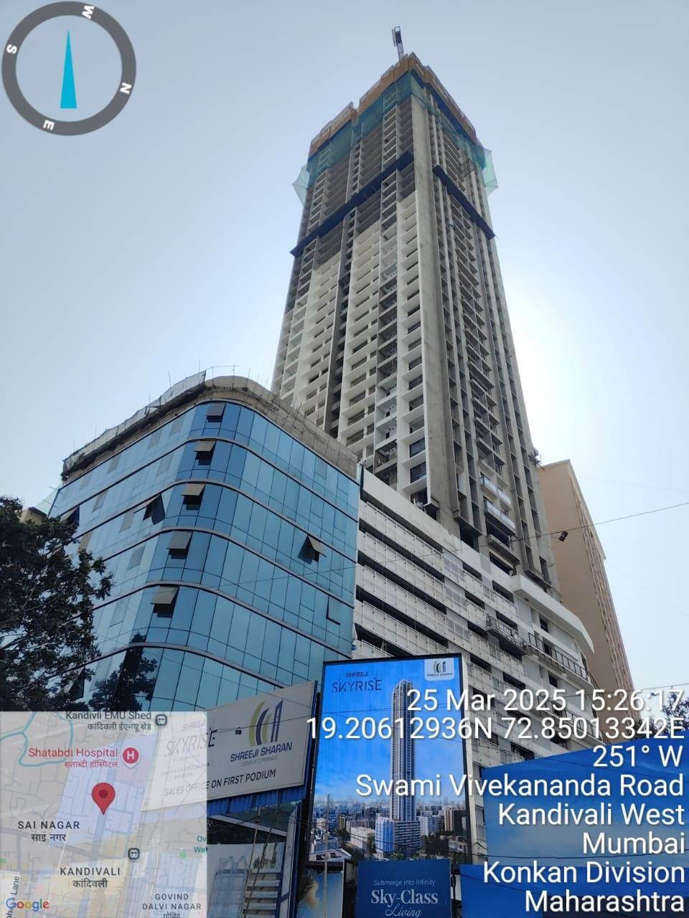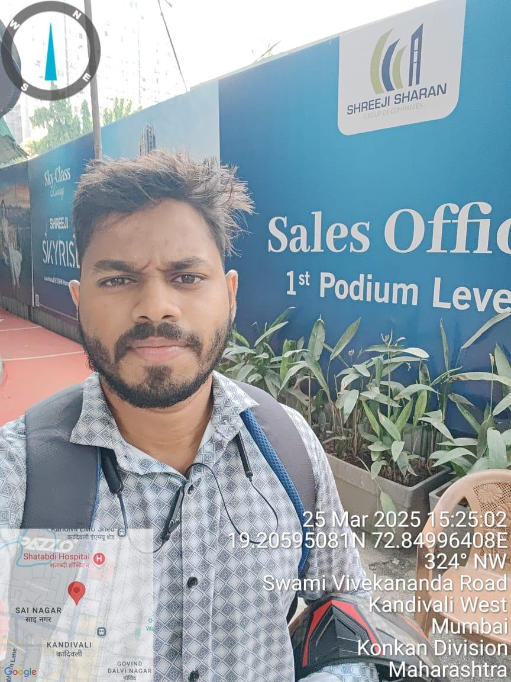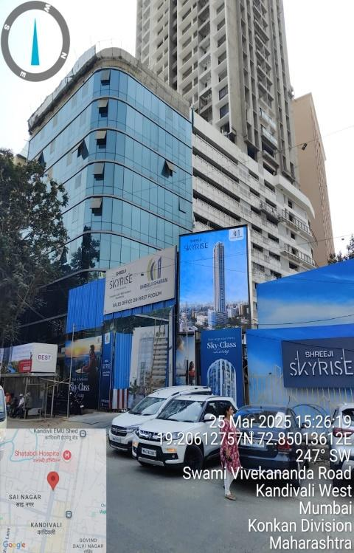

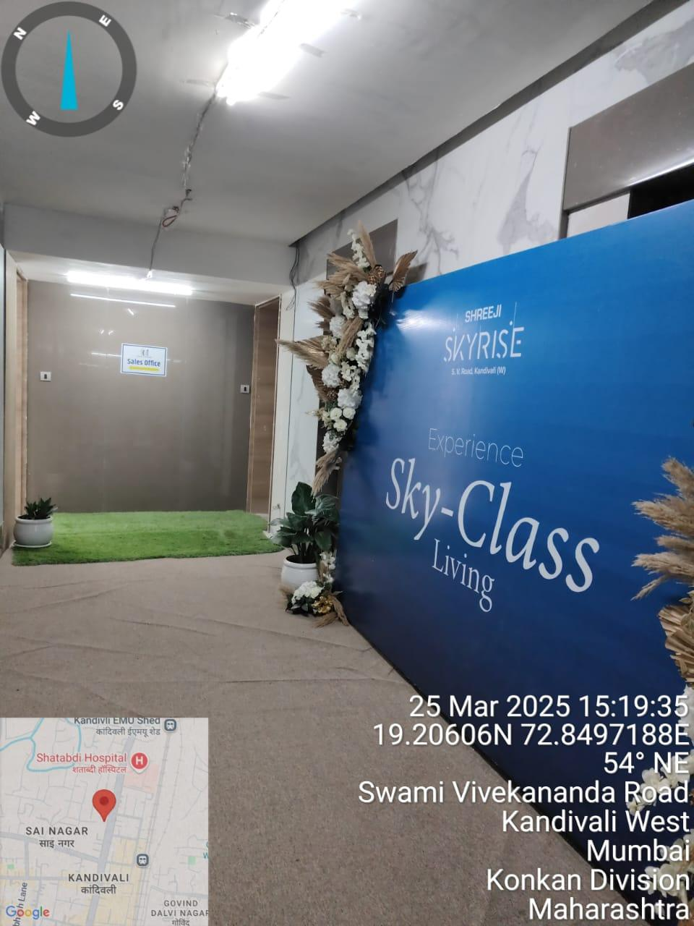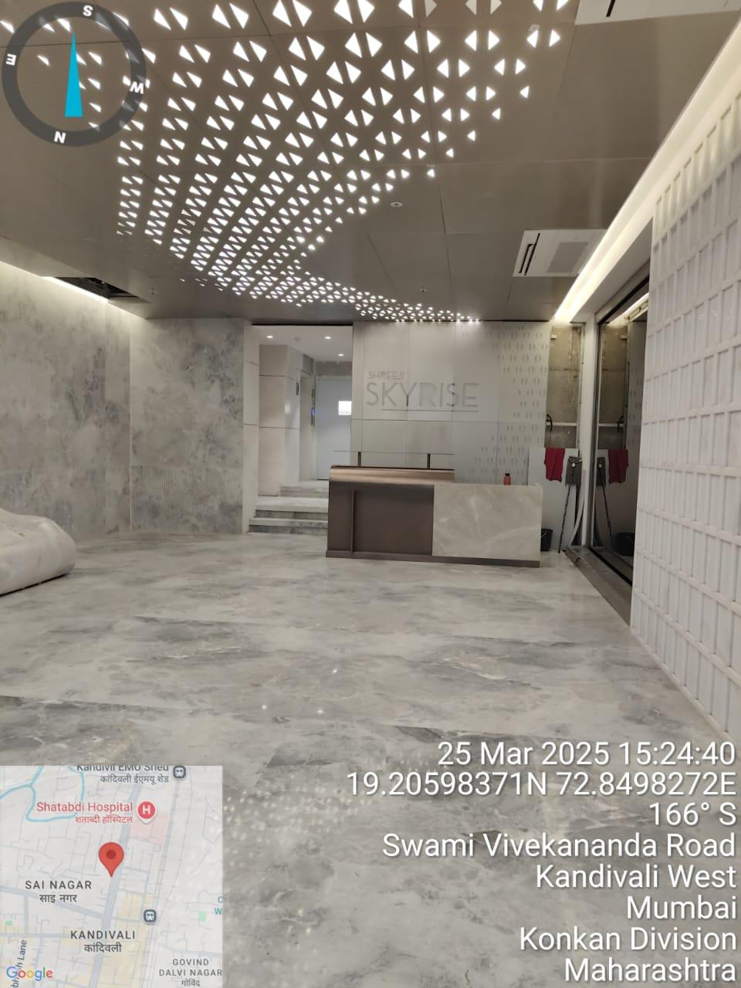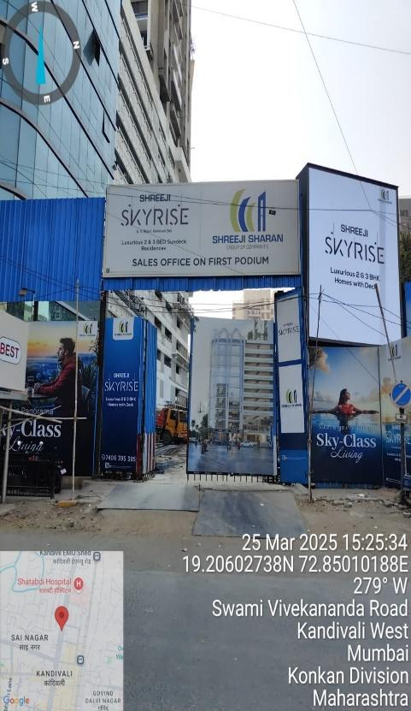

LOCATION MAP
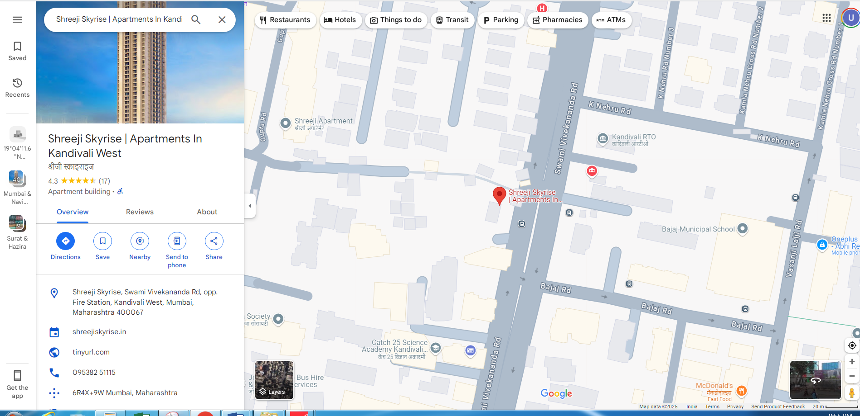

GOVERNMENT READY RECKONER 2024-2025
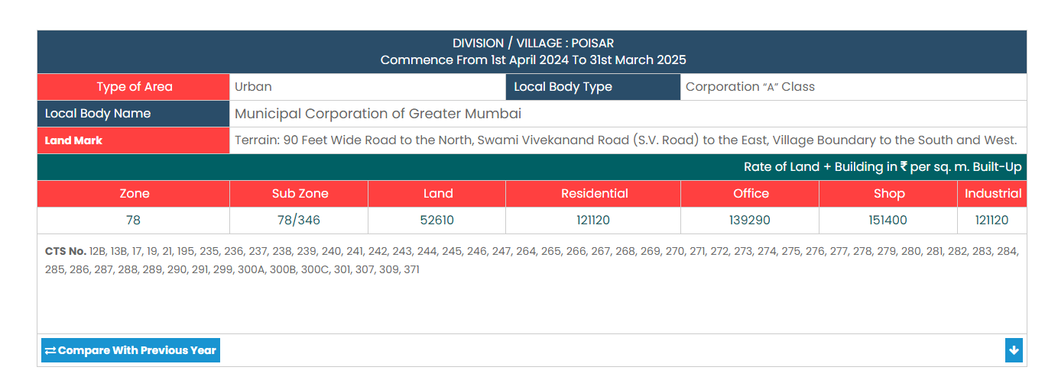

SALES COMPARABLE
